Project outline: Store price comparer. Solves my real problem of comparing price per ounce between brands without blocking aisle traffic. An app that lets you compare brand prices (based on the brands in a specific store location) accurately from your phone. Total price + tax and list price per ounce.
(Desktop version?)

Application service

Repo style pattern

ABSOLUTELY NO SPONSORSHIPS!!
No ads!
(Think of Consumer Reports, funded by fixed app price and/or donations)
No log-ins or data-tracking

“The following constraints define the RESTfulness of an application or service.
- Client-Server architecture
- Statelessness
- Uniform interface
- Layered system
- Cacheability
- Code on Demand” - here

Database of products from different brands with prices, quantity, location, etc. App serves as a detailed search of the database.

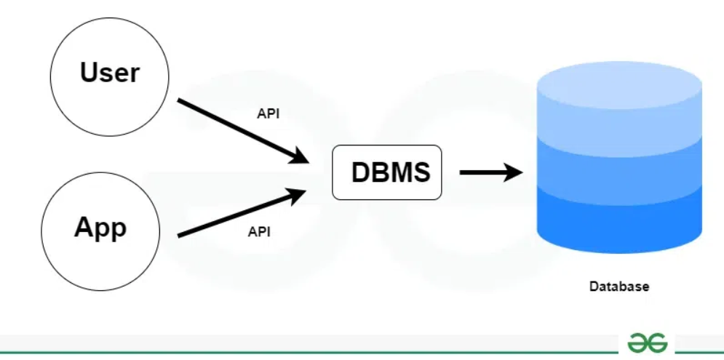

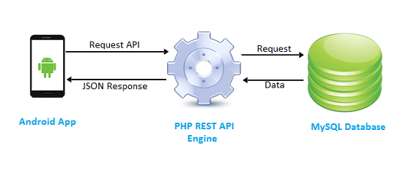
https://phppot.com/php/php-mysql-rest-api-for-android/

Requirements
1.0 User
1.1 Functional
1.1.1 Users should be able to look up and select the specific store location they are looking for.
1.1.2 Users should be able to see a list of products held at the location.
1.1.3 Users should be able to sort products by various field types (price, brand).
1.1.4 Users should be able to see the price per ounce for a product based on brand.
1.2 Non-Functional
1.2.1
2.0 System
2.1 Functional
2.1.1 The app should have an accurate and functioning search feature.
2.2 Non-Functional
2.2.1 The search bar should be visible and easy to access.
2.2.2 The system will have an up-to-date database of brand and product data.

